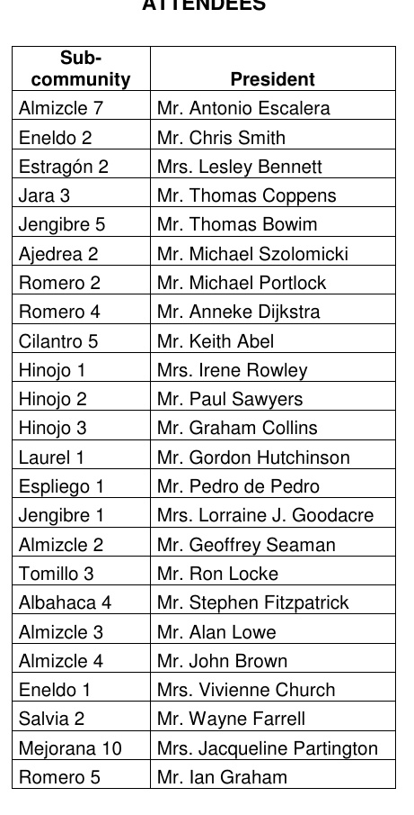
MINUTES OF THE ORDINARY GENERAL ASSEMBLY OF THE URBAN PLANNING
ENTITY OF CONSERVATION HACIENDA RIQUELME GOLF RESORT, SECTOR
ZUSUSn6, THAT TOOK PLACE PAST MONDAY, 14TH MARCH 2016, AT THE
SALÓN DE CELBRACIONES AQUARIO
The meeting, chaired by Mr. Mike Portlock, began, on second call, at 9 am with
the following
ATTENDEES
Sub
community
President
Mr. Antonio Escalera Mr. Chris Smith Mrs. Lesley Bennett Mr. Thomas Coppens Mr. Thomas Bowim Mr. Michael Szolomicki Mr. Michael Portlock Mr. Anneke Dijkstra Mr. Keith Abel Mrs. Irene Rowley Mr. Paul Sawyers Mr. Graham Collins Mr. Gordon Hutchinson Mr. Pedro de Pedro Mrs. Lorraine J. Goodacre Mr. Geoffrey Seaman Mr. Ron Locke Mr. Stephen Fitzpatrick Mr. Alan Lowe Mr. John Brown Mrs. Vivienne Church Mr. Wayne Farrell
Almizcle 7 Eneldo 2 Estragón 2 Jara 3 Jengibre 5 Ajedrea 2 Romero 2 Romero 4 Cilantro 5 Hinojo 1 Hinojo 2 Hinojo 3 Laurel 1 Espliego 1 Jengibre 1 Almizcle 2 Tomillo 3 Albahaca 4 Almizcle 3 Almizcle 4 Eneldo 1 Salvia 2 Mejorana 10 Mrs. Jacqueline Partington Romero 5
Mr. Ian Graham
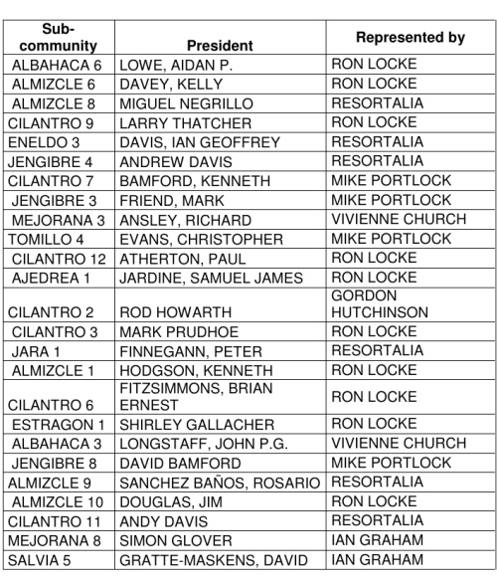
REPRESENTED
Sub
community
President
ALBAHACA 6 LOWE, AIDAN P. ALMIZCLE 6 DAVEY, KELLY ALMIZCLE 8 MIGUEL NEGRILLO LARRY THATCHER CILANTRO 9 DAVIS, IAN GEOFFREY ENELDO 3 JENGIBRE 4 ANDREW DAVIS BAMFORD, KENNETH CILANTRO 7 JENGIBRE 3 FRIEND, MARK MEJORANA 3 ANSLEY, RICHARD TOMILLO 4 CILANTRO 12 ATHERTON, PAUL AJEDREA 1
EVANS, CHRISTOPHER
JARDINE, SAMUEL JAMES
CILANTRO 2 ROD HOWARTH CILANTRO 3 MARK PRUDHOE JARA 1 ALMIZCLE 1 HODGSON, KENNETH
FINNEGANN, PETER
RON LOCKE VIVIENNE CHURCH MIKE PORTLOCK
FITZSIMMONS, BRIAN ERNEST
CILANTRO 6 ESTRAGON 1 SHIRLEY GALLACHER ALBAHACA 3 LONGSTAFF, JOHN P.G. JENGIBRE 8 DAVID BAMFORD ALMIZCLE 9 ALMIZCLE 10 DOUGLAS, JIM CILANTRO 11 ANDY DAVIS MEJORANA 8 SIMON GLOVER SALVIA 5
SANCHEZ BAÑOS, ROSARIO RESORTALIA RON LOCKE RESORTALIA IAN GRAHAM IAN GRAHAM
GRATTE-MASKENS, DAVID
Resortalia, as Secretary – Administrator, was represented by:
• Mr. Isaac Abad, Director.
• Mrs. Pepa Pérez, Resort Manager.
• Mr. Francisco Gómez, Accountancy Department.
• Mrs. Elena Bassons, Accountancy Department.
• Mr. José Francisco Nova, Financial Department.
• Mrs. Lola Pérez, Recovery Department.
• Mr. Luis Moreno, Customer care Department.
• Mrs. Ana Sánchez, Customer care Department.
• Mr. Alberto Gómez, Lawyer from the Legal Department.
1. Approval of the reconciliation of the Budget of the EUCC for the period from
1/1/2015 to 31/12/2015.
Resortalia explained that plenty information had been sent with the Call:
Financial Report, Informative Annex, Balance Sheet and Loss & Profit Account, so the
Board and Resortalia were ready to receive questions.
There were no questions. The point was put to a vote and was unanimously
approved.
2. Approval of the Budget of the EUCC for the period from 1/1/2016 to
31/12/2016.
Resortalia explained that documentation had already been sent to owners:
Financial Report and Informative Annex
Mr. Antonio Escalera asked about item 2, improvements of gardening; 9,
rubbish containers maintenance and 11, provision long term repairs and renewals.
Resortalia read the information of the Informative Annex related to those points,
so the questions were clarified.
After these explanations, the Budget 2016 was put a vote and was unanimously
approved.
3. Any Other Business.
There were no questions.
There was no further business, and being 9.25 am on Monday, 14th March 2016, the meeting was ended, recording the present minutes and certified by the Secretary
Administrator, with the approval of the President.
SECRETARY – ADMINISTRATOR
PRESIDENT

